1. **Creating and Renaming Files/Directories**

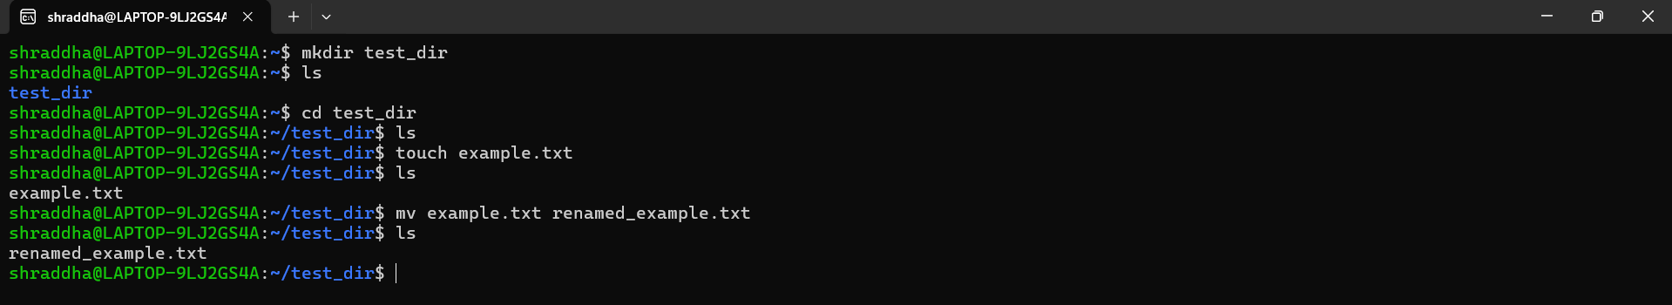

**Explanation:**

* **mkdir test_dir** → Creates a directory named **test_dir.**
* **cd test_dir** → Moves into the **test_dir** directory.
* **touch example.txt** → Creates an empty file named **example.txt.**
* **mv example.txt renamed_example.txt** → Renames the file to **renamed_example.txt.**

1. **Viewing File Contents**

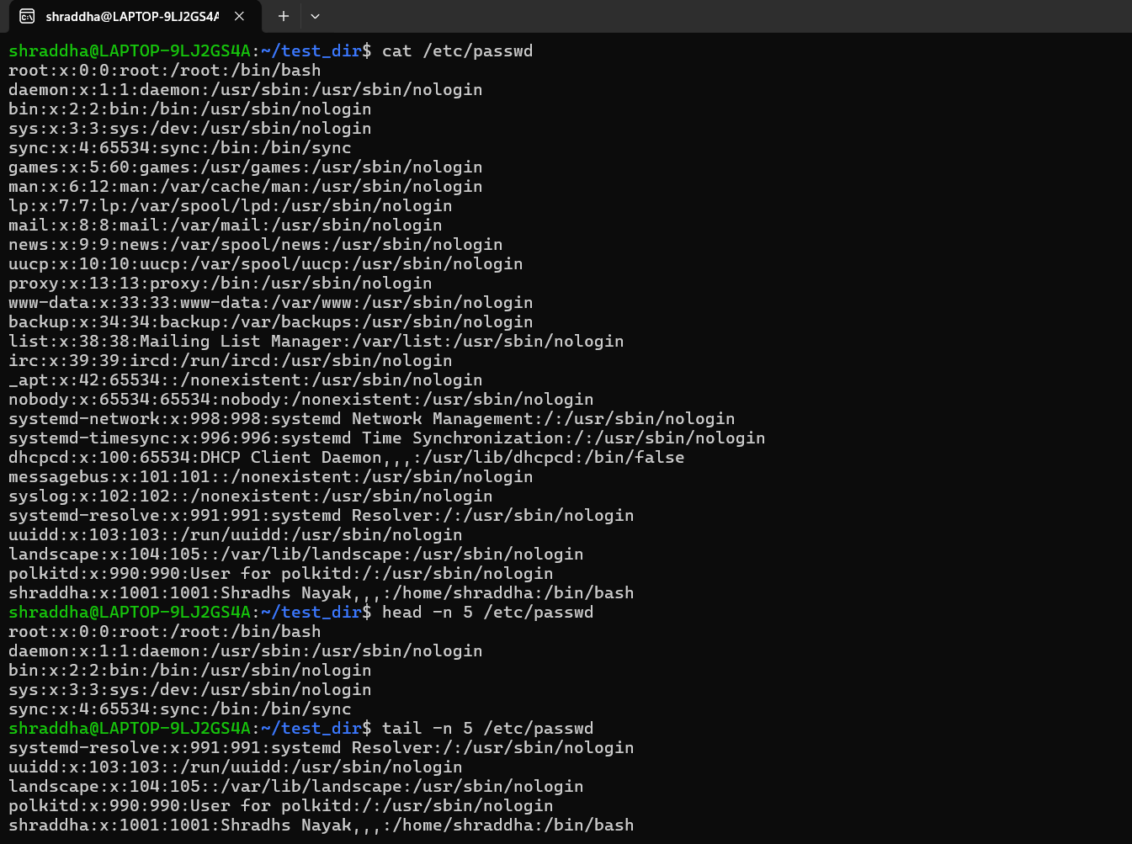

**Explanation:**

* **cat /etc/passwd** → Displays the full contents of the **/etc/passwd** file.
* **head -n 5 /etc/passwd** → Shows only the first 5 lines.
* **tail -n 5 /etc/passwd** → Shows only the last 5 lines.

**3.Searching for Patterns**

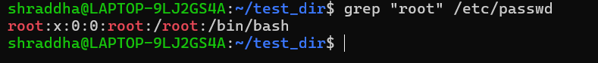

**Explanation:**

* **grep "root" /etc/passwd** → Finds and displays all lines containing the word **"root"** in the **/etc/passwd** file.

**4. Zipping and Unzipping**

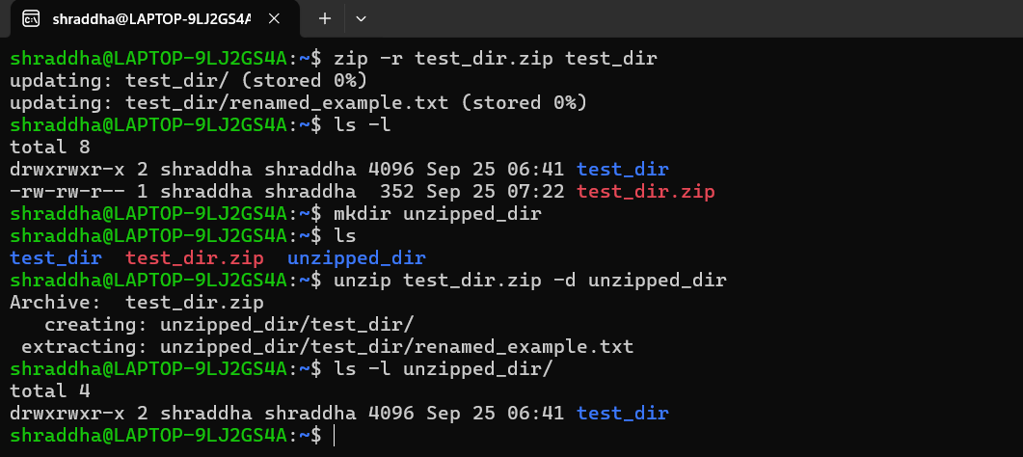

**Explanation:**

* **zip -r test_dir.zip test_dir** → Compresses **test_dir** into **test_dir.zip.**
* **mkdir unzipped_dir** → Creates a directory to extract the files into.
* **unzip test_dir.zip -d unzipped_dir** → Extracts the contents of **test_dir.zip** into **unzipped_dir.**

**5. Downloading Files**

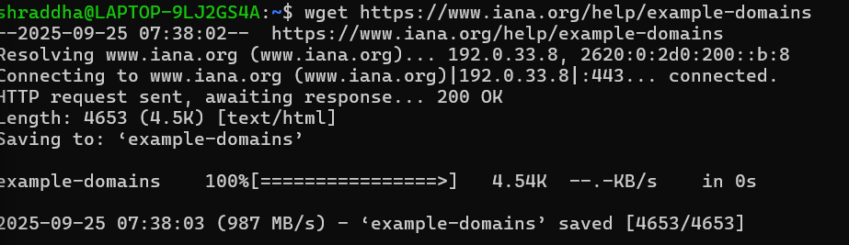

**Explanation:**

* **wget** → Downloads files from the web. (Eg: <https://www.iana.org/help/example-domains>)

**6. Changing Permissions**

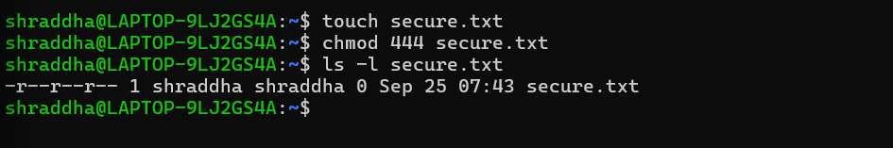

**Explanation:**

* **touch secure.txt** → Creates a file named **secure.txt.**
* **chmod 444 secure.txt** → Changes permissions to read-only for owner, group, and others.

**7. Working with Environment Variables**

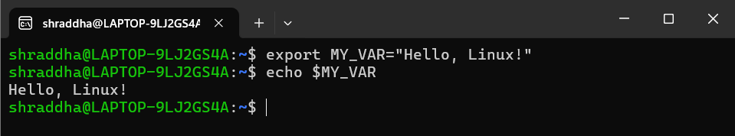

**Explanation:**

* **export MY_VAR="Hello, Linux!" →** Creates a new environment variable called **MY_VAR.**
* **echo $MY_VAR** → Displays the value of **MY_VAR.**